**AR SMART NEWSPAPER**

Submitted in the partial fulfillment of the requirements of

the degree of

**BACHELOR OF ENGINEERING IN INFORMATION TECHNOLOGY**

**By**

1. SHUBHAM PATIL (36)
2. BHAVESH PATIL (34)
3. DHIRAJ NAIK (67)

**UNDER THE GUIDANCE OF**

Prof. Pragati Pejlekar



Department of Information Technology  
Saraswati College of Engineering, Kharghar, Navi Mumbai  
University of Mumbai  
2021-22

**Saraswati College of Engineering, Kharghar**

**Vision:**

To become center of excellence in Engineering education and research.

**Mission:**

To educate students to become quality technocrats for taking up challenges in

all facets of life.

**Department of Information Technology**

**Vision:**

To create technically qualified talent through research to take up challenges in industries.

**Mission:**

1. To impart quality education.

2. To develop technical and managerial skills through training and modern teaching-learning process.

**Program Educational Objectives (PEO)**

1. To prepare the candidate for a successful career in the industry and make him acquainted with the latest software and hardware,
2. To enable student to work productively as computer engineers, including supportive teamwork and leadership roles on multidisciplinary teams,
3. Graduates are prepared to be responsible computing professionals in their own area of interest,
4. To provide the candidate with a sound foundation in mathematics, software technologies, database technologies, networking, hardware and to prepare them for post graduate studies and research programs.
5. To promote the awareness of lifelong learning among students and to introduce them to professional ethics and codes of professional practice,
6. To demonstrate effective communication skills in oral, written and electronic media.

**Program Outcomes (PO)**

**At the end of the program, a student will be able to:**

1. Apply knowledge of mathematics, science and engineering.
2. Utilize the computer engineering knowledge in all domains, viz., health care, banking and Finance, other professions such as medical, law, etc.
3. Design and conduct experiments as well as to analyze and interpret data.
4. Analyze the problem, subdivide it into smaller tasks with well-defined interface for interaction among components, and complete the task within the specified time frame and financial constraints,
5. Design a system, component or process to meet the desired needs within realistic constraints such as economic, environmental, social, political and Ethical ability,
6. Design, implement, and evaluate secure hardware and/or software systems with assured quality and efficiency,
7. Communicate effectively the engineering solution to customers/users or peers,
8. Understand professional and ethical responsibilities,
9. Understand contemporary issues and to get engaged in lifelong learning by independently and continually expanding knowledge and abilities,
10. Function in multidisciplinary teams,
11. Identify, formulate and solve engineering problems.



**(Approved by AICTE, recg. By Maharashtra Govt. DTE ,Affiliated to Mumbai University)**

**PLOT NO. 46/46A, SECTOR NO 5, BEHIND MSEB SUBSTATION, KHARGHAR,NAVI MUMBAI-410210**

**Tel. : 022-27743706 to 11 * Fax : 022-27743712 * Website: www.sce.edu.in**

**CERTIFICATE**

*This is to certify that the requirements for the project report entitled ” AR SMART NEWSPAPER ”*

*Have been successfully completed by the following students:*

Roll numbers Name

1) 36 SHUBHAM PATIL

2) 34 BHAVESH PATIL

3) 67 DHIRAJ NAIK

In partial fulfillment of Sem –VIII, **Bachelor of Engineering of Mumbai University in Information Technology** of Saraswati college of Engineering, Kharghar during the academic year 2021-22.

**Internal Guide**  **External Examiner**

(Prof. Pragati Pejlekar)

**Project co-ordinator**  **Head of Department**

(Prof. Ragini Sharma) **(**Prof. Maahi Khemchandani)

**Principal**

(Dr. Manjusha Deshmukh)

Project Report Approval for B. E.

This project report entitled (***AR Smart Newspaper***) by (***Shubham Patil, Bhavesh Patil, Dhiraj Naik***) is approved for the degree of **Bachelor of Engineering**.

Examiners  
1.---------------------------------------------  
2.---------------------------------------------

Date:  
Place:

**DECLARATION**

I declare that this written submission represents my ideas in my own words and where others ideas or words have been included. I have adequately cited and referenced the original sources. I also declare that I have adhered to all principles of academic honesty and integrity and have not misrepresented or fabricated or falsified any idea/data/fact/source in my submission. I understand that any violation of the above will be cause for disciplinary action by the Institute and can also evoke penal action from the sources which have thus not been properly cited or from whom proper permission has not been taken when needed.

----------------------------------------

(Signature)

-----------------------------------------

SHUBHAM PATIL 36

BHAVESH PATIL 34

DHIRAJ NAIK 67

Date:

**ABSTRACT**

Reading traditional newspapers or magazines is a common way to get the latest information about events or new products. However, these printed materials only provide readers with the static information. India’s newspapers grew by relying on the advertising, a dependence that began to unravel before the pandemic struck. Due to Pandemic Shutdown news dailies have shut down and journalists have lost jobs. To revive their fortunes, they are trying to build incomes from digital medium. The increasing use of Internet search function, primarily through large engines such as Google, has also changed habits of readers. Introduction of augmented reality in the newspaper publishing can bring interactive learning experience to readers life. Augmented Reality can prove to be interesting feature in newspaper which would take the readers over and beyond the inked pages. With advancements in Unity and Vuforia augmented reality can play a role in helping journalists provide information more conveniently while letting viewers get a more closer insight to news stories. The results and evaluation of the paper shows the interactive way of reading newspaper experience and can increase newspapers circulation.

**Table of Content**

**CHAPTER NO. TITLE PAGE NO.**

**1. INTRODUCTION 1**

**1.1** Background 3

**1.2** Relevance4

**2. LITERATURE SURVEY 5**

**2.1** Introduction 6

**2.2** Existing Methodologies 9

**2.3** Name of different method 12

**3. PROBLEM STATEMENT 13**

**9. SYSTEM ANALYSIS 15**

**9. SYSTEM DESIGN 21**

**5.1** Design Model – Class Diagram (Detailed Design) 22

Function Specifications (Data flow diagrams)

**5.2** Data Model - (Database Design) – if required 25

**5.3** Detailed E-R diagram 26

**6. PROJECT TIME LINE 27**

**6.1** Gantt chart 28

**7. IMPLEMENTATION, RESULTS AND TESTING 29**

**7.1** Details of Hardware and Software 30

**7.2** Results 31

**8. CONCLUSIEON AND FUTURE SCOPE 34**

**8.1** Conclusion 35

**8.2** Future Scope 35

**9. REFERENCES 36**

**10. PUBLICATIONS AND CERTIFICATES 38**

**11. ACKNOWLEDGEMENT 42**

**List of Tables**

| **Table No.** | **Title** | **Page No.** |
| --- | --- | --- |

| 2.1 | Existing Methodologies | 9 |
| --- | --- | --- |
| 2.2 | Different Method | 12 |
|  |  |  |

**List of Figures**

| **Figure No.** | **Title** | **Page No.** |
| --- | --- | --- |

| 4.2 | Working Model of AR Smart Newspaper | 17 |
| --- | --- | --- |
| 4.4 | Block Diagram for AR Smart Newspaper | 19 |
| 4.6 | Activity Diagram for AR Smart Newspaper | 20 |
| 5.1.1 | Class Diagram for AR Smart Newspaper | 22 |
| 5.1.2(a) | DFD Diagram for AR Smart Newspaper Application | 23 |
| 5.1.2(b) | DFD Diagram for AR Smart Newspaper Application | 24 |
| 5.2 | Vuforia Data Model for AR Smart Newspaper | 25 |
| 5.3 | ER Diagram for AR Smart Newspaper | 26 |
| 6.1 | Gantt Chart | 28 |
| 7.2.1 | App Start-up | 31 |
| 7.2.2 | Video related to news played on Newspaper with captions and voice | 31 |
| 7.2.3 | Result for App in Landscape mode with video playing on newspaper | 31 |
| 7.2.4 | Video related to English news played on newspaper with Hindi captions and voice | 32 |
| 7.2.5 | Video related to World news played on newspaper with captions and voice | 32 |
| 7.2.6 | Video related to Cricket news played on newspaper with captions and voice | 33 |
| 7.2.7 | Video Trailer related to Movie Advertisement played on newspaper with captions and voice | 33 |
|  |  |  |

**CHAPTER 1**

**INTRODUCTION**

Augmented Reality is an emerging technology and the applications of technology are still not fully unveiled. This paper explores a new application of augmented reality for a new direction in educational book publishing, which aims to bring interactive learning experience to life. The project takes printed newspapers to the next level by applying Augmented Reality technology to provide a unique fascinating experience to its readers on mobile devices. Augmented Reality (AR) technology composing with animation brings new digital entertainment experience to the reader of newspapers. The key feature of this paper uses the technology presents auxiliary information in the field of view of an image printed on newspaper automatically without human intervention. The project uses the technology with Android mobile device to display, videos splaying, websites and web server connectivity for newspapers.

* 1. **Background**

Augmented Reality (AR) is a combination of virtual objects and the real world . The virtual object is used to enhance the relevant information of the scene recorded from reality. Whatever users can see is the augmented information which is displayed overlaid real world objects or associated with real space in which they are observed. The user will not feel the separation between the virtual and real components. That is the main purpose is of augmented reality to blur the boundaries and the difference between real and virtual objects in order to increase awareness and interaction of human with the real world For the traditional newspaper, readers can only receive information in the form of printed papers. Although it is prevalent, users will easily get bored with the traditional way of reading news. For more information about the events they read, readers often find themselves on the website.

We can solve this problem by integrating AR technology into existing newspapers. With this approach, users can get a new experience by the interesting media has been added to the traditional newspaper. We are Creating an Application with mobile devices that can provide extra information and multimedia for readers by applying augmented reality to traditional newspapers.

* 1. **Relevance**

Reading traditional newspapers or magazines is a common way to get latest information about events or new products. However these printed materials only provide readers with static information. Readers may want to know more detail information about some product in an article or to watch video clips related to an event mentioned in a news right at the moment when they read that article or news.

Our system will solve these problem by, implementing an app in which we will be having an interactive newspaper with interactive images. The newspapers will contain the live images that will add extra detail and colour to live and adapt. We will be using latest feature of Vuforia to turn our newspaper into a magical newspaper that will play the content that is relevant to the image that is being detected. It will turn a boring and standard newspaper into something that is extremely interesting and thus it revamps the experience of reading newspaper.

**CHAPTER 2**

**LITERATURE SURVEY**

**2.1 Introduction**

In Paper [1]. An augmented reality image registration method based on improved ORB was proposed. In the process of the Augmented Reality (AR) image registration, the traditional ORB (oriented FAST and rotated BRIEF) algorithm has the low registration rate and poor real-time performance. In this paper, an improved AR image registration method based on the improved ORB is proposed. Firstly, the calibration image and video frame image feature points are obtained by improved FAST feature detection algorithm. Then, binary descriptor of BRISK, which using the custom domain sampling pattern is used for the feature description, and scale invariance of the traditional ORB algorithm is then improved. Finally, the random sampling consistency (RANSAC) algorithm is used to eliminate the wrong matching point pairs and optimize feature matching. Experiments shows that compared with the AR image registration method described by the traditional ORB algorithm and FREAK feature, the registration rate of the proposed algorithm is increased by 1.1% and 8.4%, and the generation time is then reduced by 0.13s and 0.12s, respectively. The experimental results show that AR image registration method proposed in this paper can obtain higher feature point registration rate and thus has better real-time performance, which can better meet the application needs of AR image registration

In Paper [2] Augmented Reality Application for Newspapers, they are implementing an app in which we will be having an interactive newspaper with interactive images. The newspapers will contain live images that will add extra detail to it and colour to live and adapt. They will be using latest feature of ARKit to turn our newspaper into a magical newspaper that will play the content that is relevant to the image that is being detected . It is basically a way of implementing augmented reality and pretty similar to other framework that implement augmented reality. Currently one of the most popular framework for implementing AR reality, specially when we are working with unity. Apple AR kit work in a similar way in essence that allows us to create and track correspondence between the real world space, 3D space and the virtual space that we create a model of some visual content.

In Paper [3] Examining augmented reality in journalism, they argued about use of augmented reality in journalism. Photorealistic visuals are used in the news to support the journalistic norms of accuracy and authenticity. According to these aspirational norms, visual journalism should depict events in a comprehensive, realistic, and truthful manner. These norms provide a foundation for the journalism’s role as a truth-teller in society. By claiming to operate within the these normative boundaries, journalism differentiates itself from other communication practices, such as advertising and propaganda. With its immersive features and 3D renderings of the objects, AR has the potential to contribute to the perceived accuracy, authenticity, and credibility of visuals, similar to the video and multimedia. This, in turn, can increase the perceived credibility of the news reporting. Perceived realism and sense of presence in VR have been shown to have a positive association

In Paper [4] they have explored Augmented Reality Dynamic Image Recognition Technologies Based on Deep Learning Algorithms, This paper combines a convolutional neural network that can learn good feature information with the integrated learning that has good recognition effects. In the recognition tasks of MNIST database and the CIFAR-10 database, comparison experiments were performed by adjusting the hierarchical structure, activation function, descent algorithm, data enhancement, pooling selection, and tnumber of feature maps of improved convolutional neural network. The convolutional neural network uses a pooling size of 3*3, and uses more cores (above 64), small receptive fields (2*2), and more hierarchical structures. In addition, the Relu activation function, gradient descent algorithm with momentum, and enhanced data set are also used. The research results show that under certain experimental conditions, the dynamic image recognition results have dropped to a very low error rate in the MNIST database, and the error rate in the CIFAR-10 database is also ideal.

In Paper [5] They have examined Capabilities of ARCore and ARKit Platforms for AR/VR Applications. ARCore and ARkit capabilities were scrutinized and compared. Authors established comparison criteria for both platforms, developed test applications and ran comparison tests. Obtained results can be a help in choosing the right framework to speed up prototyping and development of modern AR/VR applications. This work consists of a comprehensive comparison of these new frameworks in the following respects: general performance (CPU/memory use), mapping of planes on various surface types, influence of light and movement on mapping quality etc.

In Paper [6], they have examined the performance of 3D object detection performed on augmented reality based on the Vuforia. The research scenarios based on results of the analysis of the Vuforia working principle. The study conducted with three angles of shooting and on the several variations of light intensity and distance of the object. The research also conducted by covering part of the object's surface. The results showed that the Vuforia was able to detect those objects well in several scenarios that applied with a success rate of 87.5%. The success rate of object detection strongly influenced by the surface area of the detected object and intensity of the light space.

**2.2 Existing Methodologies**

|  |  |  |  |  |
| --- | --- | --- | --- | --- |
| **SR NO** | **YEAR** | **AUTHOR** | **TITLE OF PAPER** | **METHODOLOGY** |
| 1 | 2019 | Mingzhi Cheng, Luyue Zhang, Long LiuSeed Sowing arduino | An augmented reality image registration method based on improved ORB | In this paper, an improved AR image registration method based on improved ORB is proposed. Firstly, the calibration image and video frame image feature points improved FAST feature detection algorithm. Then, the binary descriptor of BRISK, which using the custom domain sampling pattern is used for feature description, traditional ORB algorithm is improved |
| 2 | 2021 | Author-Ihtiram Raza Khan, Anuj Goyal, Mehtab Alam | Augmented Reality Application for Newspapers | In this research paper, they are implementing an app in which we will be having an interactive newspaper with interactive images. |
| 3 | 2019 | Author- Qiuyun Cheng , Sen Zhang, Shukui Bo , Dengxi Chen , Haijun Zhang | Augmented Reality Dynamic Image Recognition Technology Based on Deep Learning Algorithm | This paper combines a convolutional neural network that can learn good feature information with integrated learning that has good recognition effects. In the recognition tasks of the MNIST database and the CIFAR-10 database, comparison experiments were performed by adjusting the hierarchical structure, pooling selection, and number of feature maps of the improved convolutional neural network. |
| 4 | 2019 | Paweł Nowacki and Marek Woda | Capabilities of ARCore and ARKit Platforms for AR/VR Applications | In this paper ARCore and ARkit capabilities were scrutinized and compared. Authors established comparison criteria for both platforms, developed test applications and ran comparison tests. Obtained results can be a help in choosing the right framework to speed up prototyping and development of modern AR/VR applications. |
| 5 | 2020 | Siti Sendari, Adim Firmansah, Aripriharta | Performance Analysis of Augmented Reality Based on Vuforia Using 3D Marker Detection | In this paper study  conducted with three angles of shooting and several variations  of light intensity and distance of the object. The results showed that the Vuforia was able to detect objects well in several scenarios that applied with a success rate of 87.5%.. |

Table 2.2: Existing Methodologies

**2.3 Name of different method**

|  |  |  |  |  |
| --- | --- | --- | --- | --- |
| **SR NO** | **YEAR** | **AUTHOR** | **TITLE OF PAPER** | **METHODOLOGY** |
| 1 | 2021 | Rahat Pervez  Diba Chowdhury  Md Sahadat Hossain Sagor  Md. Imdadul Hoque  Nafiul Islam | Augmented reality marker-based  technology for augmenting newspaper  advertisement | In this paper, One method for an AR system to recognize elements of the  physical world is through the use of so-called ‘markers’ that, when processed through the camera, alert the system that  relevant information for overlay can be downloaded from  the Internet. |

Table 2.3: Different Method

**CHAPTER 3**

**PROBLEM STATEMENT**

The increasing use of Internet search function, primarily through large engines such as Google, has also changed habits of readers. Instead of perusing the general interest publications, such as newspapers, readers are more likely to seek particular writers, blogs or sources of information through targeted searches, rendering the agglomeration of the newspapers increasingly irrelevant. India’s newspapers grew by relying on the advertising, a dependence that began to unravel before the pandemic struck. News Dailies have shut down and journalists have lost jobs. To revive their fortunes, they are now—belatedly—trying to build incomes from digital medium. So, we are using Augmented Reality, and taking advantages of new digital news boom for readers to return to newspapers again.

We will be using latest feature of Vuforia to turn our newspaper into a magical newspaper that will play the content that is relevant to the image that is being detected. It will turn a boring and standard newspaper into something that is extremely interesting and it revamps the experience of reading the newspaper. As Providing AR coverage of certain inventions makes a news story a lot less abstract, giving viewers the freedom of visualization. Our AR Smart newspaper will, play a role in helping journalists provide information more conveniently while letting viewers get a more closer insight to stories.

**CHAPTER 4**

**SYSTEM ANALYSIS**

**4.1. Methodology**

The increasing use of Internet search function, primarily through large engines such as Google, has also changed habits of readers. Introduction of augmented reality in the newspaper publishing can bring interactive learning experience to readers life. Augmented Reality can prove to be interesting feature in newspaper which would take the readers over and beyond the inked pages. With advancements in Unity and Vuforia augmented reality can play a role in helping journalists provide information more conveniently while letting viewers get a more closer insight to news stories.

The main objective of this project is to develop an android newspaper application which uses augmented reality. languages used will be swift, ShadderLab and C#. For Video asset rendering we will be using Unity Engine and for image tracking, scanning and database we will be using Vufria. The software product of this project, from the business perspective, creates a new business marketing dimension in digital publishing and increases the selling profits in the newspaper publication business.

**4.2. Working**

We are using unity for development of aur application, we will be creating multiple image targets for different types of news in our project. For database we are using Vuforia sdk. We will build our application for android using unity android sdk. In our application The back camera of the device will search for a scene and when it recognizes the scene using Vuforia Image Tracking, by scanning the image in the newspaper, then the video is played in its position which livens up the experience of reading a newspaper. All this video assets for newspaper will be rendered in Unity and image tracking and recognition will be done using Vuforia. We will be using latest feature of Vuforia to turn our newspaper into a magical newspaper that will play the content that is relevant to the image that is being detected. We will include news for various categories and will include relevant content related to it in our application.

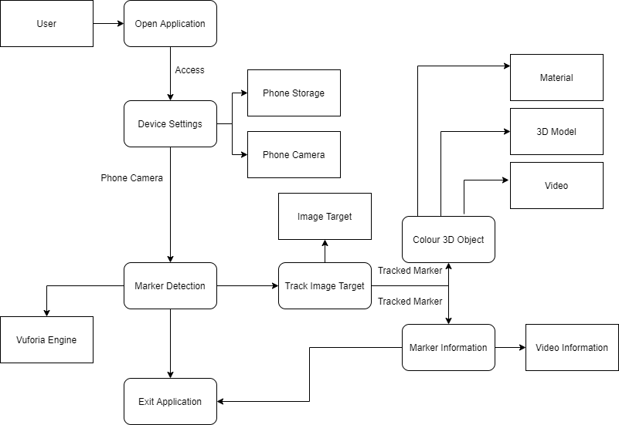

Fig 4.2: Working Model of AR Smart Newspaper

**4.3. Algorithm**

1. Open the AR Smart Newspaper App
2. Allow Camera Permission to the app.
3. Click the AR symbol on the front page of the app.
4. The app opens the camera application on the iPad in scan mode. Fill the screen with the photo to be scanned.
5. The photo is automatically scanned as a vertical green line moves over the photo. Markers (the green dots in two of the photos below) are temporarily laid down as the scan line moves.
6. Information from the markers is sent to a newspaper computer.
7. The computer compares the information from the scanned photo with the photo information stored in its database until it finds matching data.
8. Once a match is found, the computer performs the action that it's programmed to carry out when that photo has been identified (such as loading a particular video or slide show).

**4.4. Block Diagram**

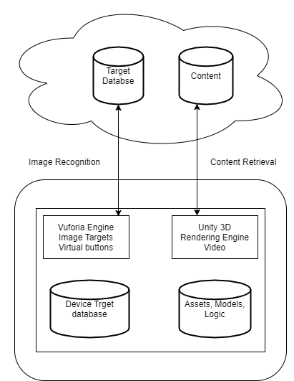

Fig 4.4: Block Diagram for AR Smart Newspaper

**4.6. Activity Diagram**

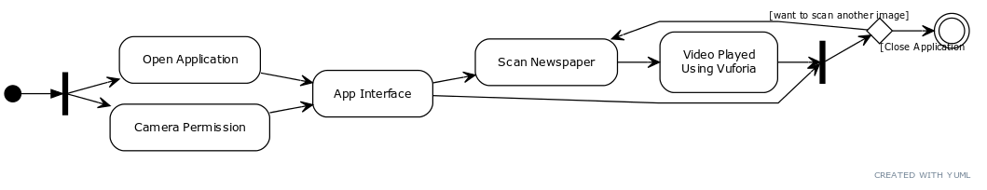

Fig 4.6: Activity Diagram for AR Smart Newspaper

**CHAPTER 5**

**SYSTEM DESIGN**

**5.1 Design Model –**

**Class Diagram (Detailed Design)**

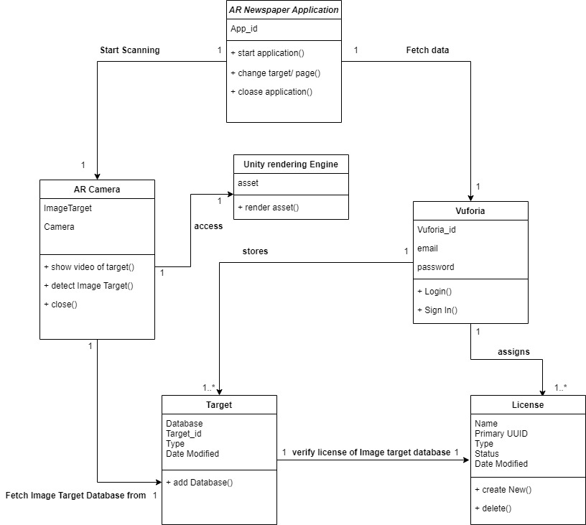

Fig 5.1.1: Class Diagram for AR Smart Newspaper

**Function Specifications (Data flow diagrams)**



Fig 5.1.2(a): DFD Diagram for AR Smart Newspaper Application

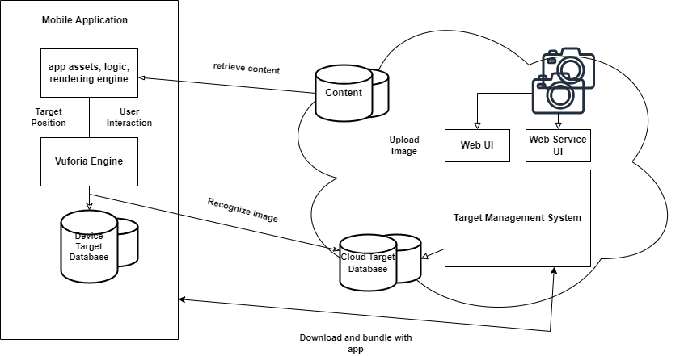

Fig 5.1.2(b): DFD Diagram for AR Smart Newspaper Application

**5.2 Data Model - (Database Design) – if required**

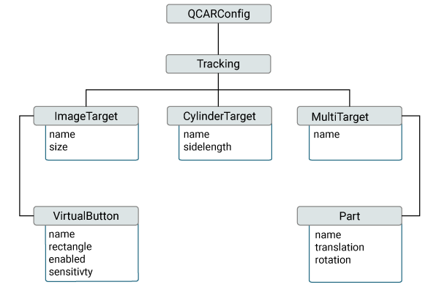

Fig 5.2: Vuforia Data Model for AR Smart Newspaper

**5.3 Detailed E-R diagram**

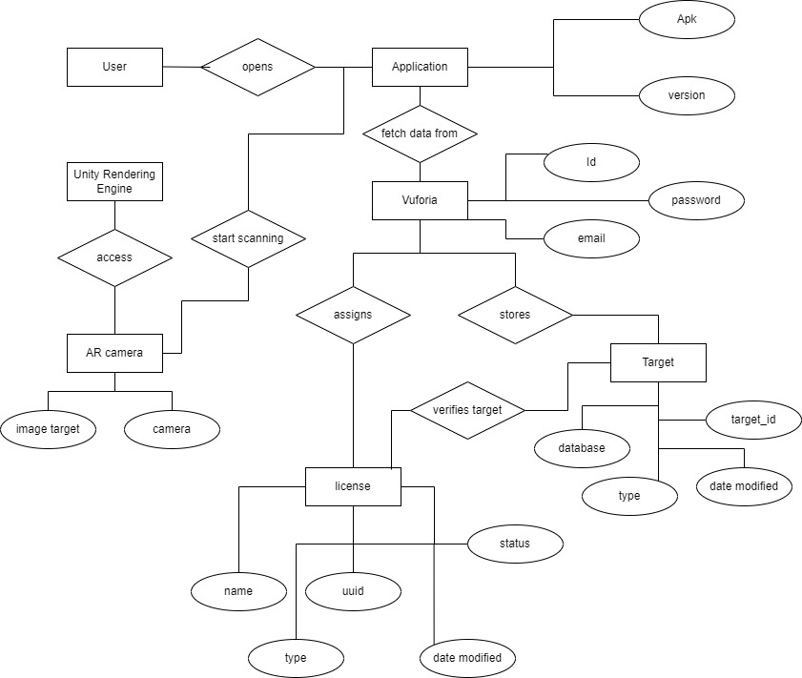

Fig 5.3: ER Diagram for AR Smart Newspaper

**CHAPTER 6**

**PROJECT TIME LINE**

**6.1 Gantt chart**

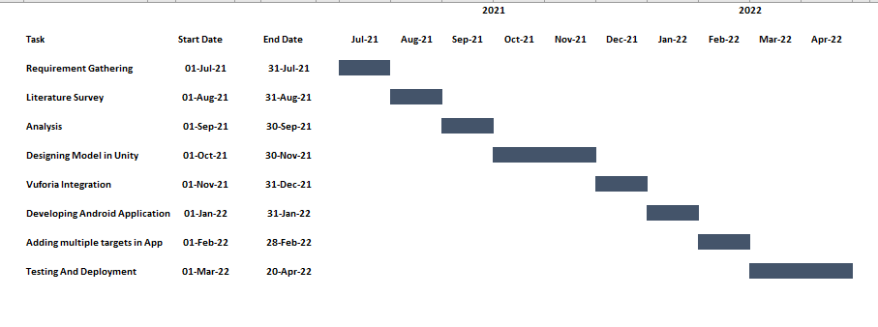

Fig 6.1: Gantt Chart

**CHAPTER 7**

**IMPLEMENTATION, RESULTS AND TESTING**

**7.1 Details of Hardware and Software**

**Hardware Specification**

* Android Smartphone
* I3+ Processor System
* Sensors like Accelerometer, Gyroscope, Magnetometer
* Camera

**Software Specification**

* Vuforia
* Unity
* Android Studio Sdk

**7.2 Results**

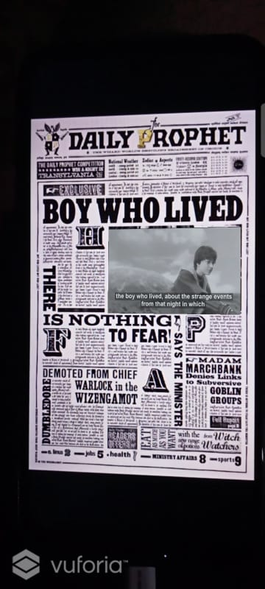

Fig 7.2.1: App Start-up

Fig 7.2.2: Video related to news played

on Newspaper with captions and voice.



Fig 7.2.3: Result for App in Landscape mode with

video playing on newspaper

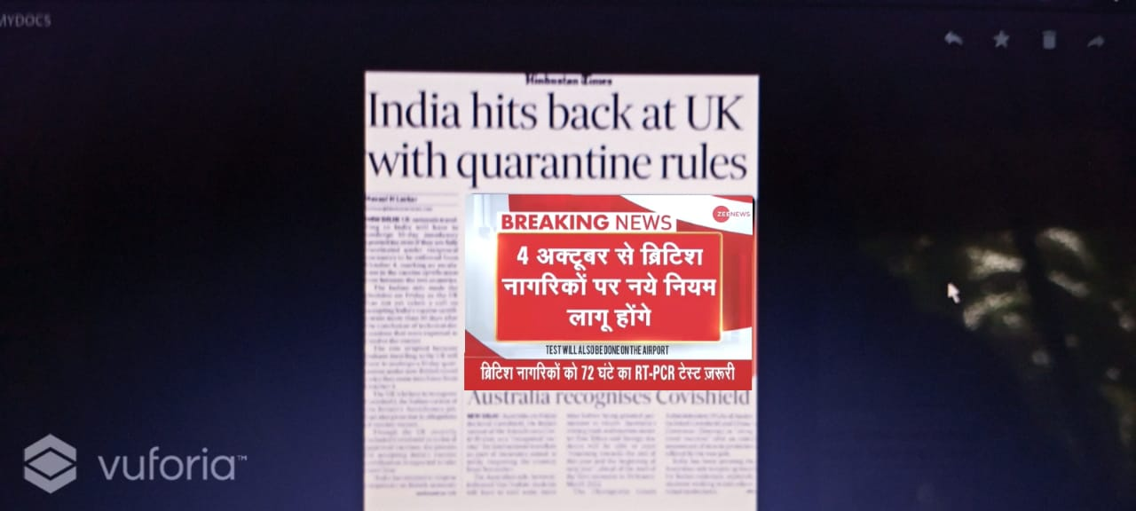

Fig 7.2.4: Video related to English news played on newspaper with hindi

captions and voice

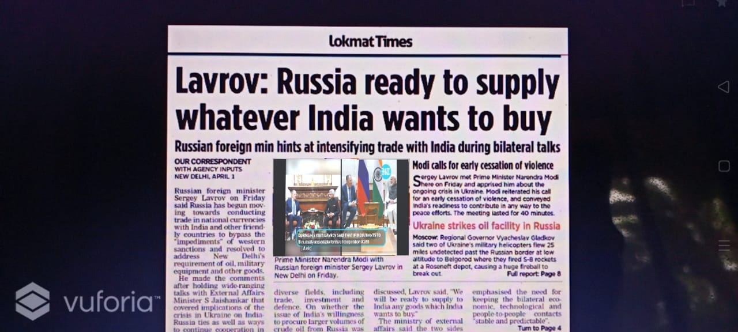

Fig 7.2.5: Video related to World news played on newspaper with

captions and voice

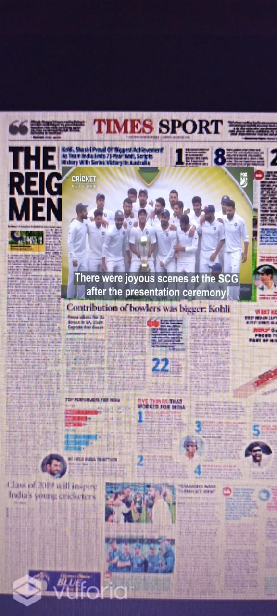 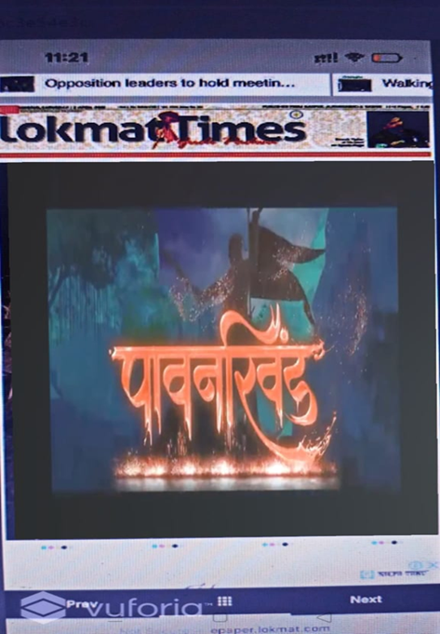

Fig 7.2.7: Video Trailer related to Movie Advertisement played on newspaper with captions and voice

Fig 7.2.6: Video related to Cricket news played on newspaper with captions and voice

**CHAPTER 8**

**CONCLUSION AND FUTURE SCOPE**

**8.1 Conclusion**

We can create a successful way of human interaction with the newspaper with the help of AR Smart Newspaper, So by taking advantages of digital boom we can strike a balance between AR and Newspaper. For the future developments it can be enhanced by developing this system for big newspapers or magazines..

**8.2 Future Scope**

In future development, smart newspapers, which can give full play to the advantages of the augmented reality technology, will create a more realistic integration world for us human beings. As People can interact with the system in a more natural way of human-computer interaction using AR

**CHAPTER 9**

**REFERENCES**

[1] An augmented reality image registration method based on improved ORB - Mingzhi Cheng, Luyue Zhang, Long LiuSeed Sowing arduino. (2019).

[2] Augmented Reality Application for Newspapers - Ihtiram Raza Khan, Anuj Goyal, Mehtab Alam

[3] Examining augmented reality in journalism: Presence, knowledge gain, and perceived visual authenticity -Tanja Aitamurto, Laura Aymerich-Franch, Jorge Saldivar, Catherine Kircos, Yasamin Sadeghi, Sukolsak

[4] Sakshuwong Multi-Agent Planning for Coordinated Robotic Weed Killing(2018)

[5] Augmented Reality Dynamic Image Recognition Technology Based on Deep Learning Algorithm - Author: Qiuyun Cheng , Sen Zhang, Shukui Bo , Dengxi Chen , Haijun Zhang

[6] Capabilities of ARCore and ARKit Platforms for AR/VR Applications - Paweł Nowacki and Marek Woda

[7] Performance Analysis of Augmented Reality Based on Vuforia Using 3D Marker Detection - Siti Sendari, Adim Firmansah, Aripriharta

[8] Augmented reality marker-based technology for augmenting newspaper advertisement - Rahat Pervez, Diba Chowdhury, Md Sahadat Hossain Sagor, Md. Imdadul Hoque, Nafiul Islam

**CHAPTER 5**

**PUBLICATIONS AND CERTIFICATES**

**ACKNOWLEDGEMENT**

After the completion of this work, words are not enough to express feelings about all those who helped us to reach goal. It’s a great pleasure and moment of immense satisfaction for us to express my profound gratitude to **Project Guide**, **Prof. Pragati Pejlekar** whose constant encouragement enabled us to work enthusiastically. His perpetual motivation, patience and excellent expertise in discussion during progress of the project work have benefited us to an extent, which is beyond expression.

We would also like to give our sincere thanks to **Prof. Maahi Khemchandani, Head of Department**, and **Prof. Ragini Sharma, Project co-ordinator** from Department of Information technology, Saraswati College of Engineering, Kharghar, Navi Mumbai, for their guidance, encouragement and support during a project.

I am thankful to **Dr. Manjusha Deshmukh, Principal,** Saraswati College of Engineering, Kharghar , Navi Mumbai for providing an outstanding academic environment, also for providing the adequate facilities.

Last but not the least we would also like to thank all the staffs of Saraswati college of Engineering (Information Technology Department) for their valuable guidance with their interest and valuable suggestions brightened us.

**Shubham Patil**

**Bhavesh Patil**

**Dhiraj Naik**